Title: Decoding and prediction of individual neural representations of emotion processing with a scalable tensor-based principle

Authors:
Rongquan Zhai, B.S.^{1,2}; Weiyang Ding, Ph.D.^{1,2,31};Tobias Banaschewski, Ph.D.³; Gareth J. Barker, Ph.D.²²; Arun L.W. Bokde, Ph.D.⁴; Rüdiger Brühl, Ph.D.⁵; Sylvane Desrivières, Ph.D.⁶; Herta Flor, Ph.D.^{7,8}; Hugh Garavan, Ph.D.⁹; Penny Gowland, Ph.D.¹⁰; Antoine Grigis, Ph.D.¹¹; Andreas Heinz, Ph.D.¹²; Jean-Luc Martinot, Ph.D.¹³; Marie-Laure Paillère Martinot, Ph.D.^{13,14}; Jani Penttilä, Ph.D.²³; Eric Artiges, Ph.D.^{13,15}; Frauke Nees, Ph.D.^{3,16}; Dimitri Papadopoulos Orfanos, Ph.D.⁸; Tomáš Paus, Ph.D.¹⁷; Luise Poustka, M.D.¹⁸; Michael N. Smolka, M.D.¹⁹; Sarah Hohmann, Ph.D.³; Nathalie Holz, Ph.D.³; Christian Baeuchl, Ph.D.²⁴; Herve Lemaitre, Ph.D.²⁵; Nilakshi Vaidya, M.Sc.²⁰; Henrik Walter, Ph.D.¹²; Robert Whelan, Ph.D.²¹; Gunter Schumann, Ph.D. ^{19, 26}; IMAGEN Consortium; Shitong Xiang, Ph.D.^{1,2*}; Tianye Jia, Ph.D.^{1,2,6,27*}; Jianfeng Feng, Ph.D.^{1,2,28,29,30*}

Affiliations:
¹ Institute of Science and Technology for Brain-Inspired Intelligence, Fudan University, Shanghai, China.
² Key Laboratory of Computational Neuroscience and Brain-Inspired Intelligence (Fudan University), Ministry of Education, Shanghai, China.
³ Department of Child and Adolescent Psychiatry and Psychotherapy, Central Institute of Mental Health, Medical Faculty Mannheim, Heidelberg University, Square J5, 68159 Mannheim, Germany; German Center for Mental Health (DZPG), partner site Mannheim-Heidelberg-Ulm
⁴ Discipline of Psychiatry, School of Medicine and Trinity College Institute of Neuroscience, Trinity College Dublin, Dublin, Ireland;
⁵ Physikalisch-Technische Bundesanstalt (PTB), Braunschweig and Berlin, Germany;
⁶ Social, Genetic and Developmental Psychiatry Centre, Institute of Psychiatry, Psychology & Neuroscience, King’s College London, United Kingdom;
⁷ Institute of Cognitive and Clinical Neuroscience, Central Institute of Mental Health, Medical Faculty Mannheim, Heidelberg University, Square J5, Mannheim, Germany;
⁸ Department of Psychology, School of Social Sciences, University of Mannheim, 68131 Mannheim, Germany;
⁹ Departments of Psychiatry and Psychology, University of Vermont, 05405 Burlington, Vermont, USA;
¹⁰ Sir Peter Mansfield Imaging Centre School of Physics and Astronomy, University of Nottingham, University Park, Nottingham, United Kingdom;
¹¹ NeuroSpin, CEA, Université Paris-Saclay, F-91191 Gif-sur-Yvette, France;
¹² Department of Psychiatry and Psychotherapy CCM, Charité – Universitätsmedizin Berlin, corporate member of Freie Universität Berlin, Humboldt-Universität zu Berlin, and Berlin Institute of Health, Berlin, Germany;
¹³ Institut National de la Santé et de la Recherce Médicale, INSERM U A10 "Trajectoires développementales & psychiatrie", University Paris-Saclay, Ecole Normale Supérieure Paris-Saclay, CNRS; Centre Borelli, Gif-sur-Yvette, France;
¹⁴ AP-HP. Sorbonne Université, Department of Child and Adolescent Psychiatry, Pitié-Salpêtrière Hospital, Paris, France;
¹⁵ Psychiatry Department, EPS Barthélémy Durand, Etampes, France;
¹⁶ Institute of Medical Psychology and Medical Sociology, University Medical Center Schleswig Holstein, Kiel University, Kiel, Germany;
¹⁷ Department of Psychiatry and Neuroscience, Faculty of Medicine and Centre Hospitalier Universitaire Sainte-Justine, University of Montreal, Montreal, Quebec, Canada;
¹⁸ Department of Child and Adolescent Psychiatry, Center for Psychosocial Medicine, University Hospital Heidelberg, Heidelberg, Germany;
¹⁹ Department of Psychiatry and Psychotherapy, Technische Universität Dresden, Dresden, Germany;
²⁰ Centre for Population Neuroscience and Stratified Medicine (PONS), Department of Psychiatry and Psychotherapy, Charité Universitätsmedizin Berlin, Germany;
²¹ School of Psychology and Global Brain Health Institute, Trinity College Dublin, Ireland;
²² Department of Neuroimaging, Institute of Psychiatry, Psychology & Neuroscience, King’s College London, United Kindom;
²³ Department of Social and Health Care, Psychosocial Services Adolescent Outpatient Clinic Kauppakatu 14, Lahti, Finland;
²⁴ Department of Psychiatry and Psychotherapy, Technische Universität Dresden, Dresden, Germany
²⁵Neurofunctional Imaging Group, Institute of Neurodegenerative Diseases, the neuroscience Departement of Bordeaux University, France.
²⁶ Centre for Population Neuroscience and Precision Medicine (PONS), Institute for Science and Technology of Brain-inspired Intelligence (ISTBI), Fudan University, Shanghai, China.
²⁷ School of Psychology, Southampton University, Southampton, UK.
²⁸ School of Mathematical Sciences and Centre for Computational Systems Biology, Fudan University, Shanghai, China.
²⁹ Department of Computer Science, University of Warwick, Coventry, UK.
³⁰ Fudan ISTBI–ZJNU Algorithm Centre for Brain-inspired Intelligence, Zhejiang Normal University, Jinhua, China.
³¹ MOE Frontiers Center for Brain Science, Fudan University, Shanghai, China
* Correspondence authors:
Tianye Jia (Email: tianyejia@fudan.edu.cn) or Jianfeng Feng (Email: jianfeng64@gmail.com) or Shitong Xiang (Email: shitongx@fudan.edu.cn)

Abstract
Identifying neural representations of cognitive processes remains a central challenge in brain imaging research. Here, we introduce a novel tensor decomposition-based analytical framework to decode emotional face processing at both the time-series and task-condition levels. The decomposed temporal (or conditional) and spatial neural representations demonstrated high consistency with traditional contrast-based analyses. Furthermore, individual process-specific scores derived from decomposition showed robust associations with emotion-related phenotypes, such as depressive symptoms. By extending this novel analytical framework to longitudinal data, we could impute the neural responses for missing task conditions at certain time points using shared components across time points. As an example, we implement our method on a large (N = 618) longitudinal (ages 14, 19 and 23) emotional fMRI cohort study (IMAGEN). Notably, predictions incorporating prior knowledge of additional contrast-based neural representations achieved higher accuracy, highlighting the scalability and robustness of our approach. More importantly, such imputation could advance the modeling of cognitive processes and facilitate brain-wide association studies. Altogether, we anticipate our novel analytical principle to be applied generally in decoding and predicting neurobehavioral processes.
Keywords: Longitudinal Emotional fMRI data, Tensor Decomposition, Stable neuro-behavior marker, Canonical Correlation Analysis, Brain activation prediction

- Introduction
Decoding latent processing from functional magnetic resonance imaging (fMRI) data has long been a central challenge in neuroimaging research. While numerous decomposition approaches have been proposed to interpret fMRI signals and predict associated cognitive processes (Cohen et al., 2017; Lee et al., 2013; Luppi et al., 2024; Poldrack & Farah, 2015), most of these methods rely on reducing the data dimensionality according to predefined cognitive models driven by experimental design. This practice limits the exploration of brain dynamics by enforcing narrow, model-based constraints and often overlooks the richness of multidimensional neural representations (Beckmann & Smith; Kober et al., 2008; Li et al., 2021; Lindquist et al., 2012; Phan et al., 2002).

Classical contrast-based fMRI analysis methods (Friston et al., 1994; Smith & Nichols, 2018), often limit research to comparisons between a few predefined task-conditions and focus on group-level analyses (Fusar-Poli et al., 2009; Yarkoni et al., 2011), leaving a critical gap in individualized signal decomposition and analysis. While multivariate techniques like Independent Component Analysis (ICA) (Beckmann & Smith) provide spatial features, they fail to characterize temporal dynamics and individual-level covariation. With the growing emphasis on understanding the dynamics of brain function, there is a shift toward exploring spatial-temporal interactions and associations (Bullmore & Sporns, 2012; Giedd et al., 2015; Liu et al., 2022). Tensor-based analysis methods have been successfully applied in brain imaging studies(Davidson et al., 2013; Hou & Chaib-Draa, 2015; Karahan et al., 2015; Li et al., 2021; Ma et al., 2016; Zhou et al., 2013). Notably, recent advancements in tensor-based methods (Li et al., 2021) have incorporated spatiotemporal characterization. High-dimensional analyses offer the potential to uncover deeper insights into brain mechanisms by capturing these dynamics comprehensively (Roads & Love, 2024). However, the current tensor-based approach still falls short of identifying individualized biomarkers. Developing high-dimensional individualized analytical methods is crucial for understanding the cognitive mechanisms underlying neural processes, extracting meaningful low-dimensional neural representations, even predicting unknown neural activities in the brain.
Notably, the need for individualized, high-dimensional representations is particularly pronounced in longitudinal neuroimaging studies, which hold great potential for enhancing the stability and reproducibility of brain-behavior associations across developmental stages or in relation to mental disorders (Kang et al., 2024). However, the collection of longitudinal data is inherently difficult due to protracted study durations, evolving experimental designs, and cross-site variability, often leading to missing or mismatched task conditions (Matta et al., 2018). These data limitations hinder comprehensive temporal modeling and reduce effective sample sizes. Therefore, a critical need exists for analytical approaches that not only model latent neurocognitive processes robustly but also tolerate data sparsity and even predict missing neural signals for unobserved task conditions. Such predictive capacity could dramatically enhance the utility of longitudinal datasets by maximizing available information.
To address these limitations, we propose a comprehensive tensor-based decomposition framework designed for individualized and temporally-aware fMRI analysis. Applying this method to the large-scale longitudinal IMAGEN cohort (N = 618 at ages 14, 19, and 23; (Schumann et al., 2010)), we focus on decoding brain representations during an emotional face task. Our approach enables decomposition of the fMRI signal at both the time-series and task-condition level, yielding components that jointly encode consistent spatial, temporal, and individual-specific features. These coupled components facilitate the identification of stable neuro-behavioral associations across development. Moreover, leveraging the learned component structure, we demonstrate the model’s capacity to accurately impute missing neural responses—for example, reconstructing baseline (age 14) responses to the “happy” condition that were not acquired. We anticipate that this novel high-dimensional approach will offer a powerful tool for uncovering and predicting latent neurobehavioral processes, especially in settings with incomplete or longitudinal data.

- Results
2.1 Participants, task design, data preparation and decoding method
This study utilized fMRI data (N = 618) from the IMAGEN (Schumann et al., 2010) dataset collected during the emotion face task at three time points: baseline (14 years old), follow-up2 (19 years old), and follow-up3 (23 years old). The standard and detailed operating procedures for the IMAGEN project are available at https://imagen-project.org/. The study conforms to each site's Institutional Review Board's rules and procedures, and all participants provide informed consent.

The emotional face task (EFT) employed in this investigation was adapted from a previous study(Grosbras & Paus, 2006). The detailed experiment paradigm can be found in Supplementary Figure. 1. Notably, the experimental design in the IMAGEN dataset varied across the three time points. During the baseline at 14 years old, participants were passively engaged in observing five angry faces, five neutral faces, and control stimuli. However, in follow-up2 at 19 years old and follow-up3 at 23 years old, participants were passively observing four happy faces, four angry faces, four neutral faces, and control stimuli. For raw BOLD signal, the data were reconstructed in a 3-D tensor of size (number of voxels (67683) x number of time points (155 at baseline or 197 at follow-up2 and follow-up3) x number of individuals (618)). For the task-condition response signal, the data were reconstructed into a tensor of size (number of voxels (67683) x number of task-conditions (11 at baseline or 13 at follow-up2 and follow-up3) x number of individuals (618)). We apply Canonical Polyadic (CP) decomposition method (Li et al., 2021) to identify coupled spatial, temporal, and individual features based on above two types of tensors. In the subsequent analysis, we only consider top 10 derived CP components for analysis due to computational constraints (Figure. 1, see Method section and Supplementary Materials for more details).
2.2 CP decomposition results for BOLD signals formed tensor

At three different time points, we performed CP decomposition on tensors composed of 618 individuals. Among the ten components extracted, the spatial and individual levels features’ dimensions were consistent across the three time points, while the temporal components differed due to the experimental design. First, we plotted the histograms of the mean similarities of the corresponding spatial and individual components across the time sites. We found that only the third component was significant, while the remaining nine were not, indicating that only the third CP component was stable across time points, as shown in Figure. 2a.
Subsequently, we associated the ten CP components of space, time, and individuals at the three time points with various contrasts derived from the traditional first-level analysis and the BOLD signals from the first-level analysis at each time point. The third component consistently showed the highest correlation across the three time points, as shown in Figure. 2b.
We associated the spatial and temporal components of the third CP component, derived from the BOLD signals formed tensors at three time points, with various contrast maps from classical first-level analysis and face>control BOLD signals derived from SPM (Friston et al., 1994). Both showed significant correlations, see in Figure. 2c, d. Interestingly, we found that apart from the third temporal component high correlation with BOLD signal derived from SPM (Friston et al., 1994), we found that first two temporal components are significantly correlated with global signal but not in third temporal component, see in Supplementary Figure. 2a. Also, that first two temporal components are not significantly correlated with SPM derived face>control BOLD signal derived from SPM (Friston et al., 1994), see in Supplementary Table. 1. In fMRI BOLD signals, a large portion consists of noise and global mean signal (Liu, 2016). Therefore, the first two decomposed CP components are likely to be some low-frequency signals, while the third component is the signal specifically related to the task, representing particular neural activities. Additionally, we performed CCA analysis on each individual's third component and their internalizing and externalizing scales (Xie et al., 2023). We found that the individual components extracted at the three time points could effectively explain internalizing and externalizing behaviors, see in Figure. 2e. Moreover, we discovered a stable positive correlation between the third individual component and depression across the three time points, see in Figure. 2f.
Based on the decomposition of these 618 individuals, we discovered stable spatiotemporal features. In addition to these 618 individuals, there were also other individuals at each time point. We used the third stable component extracted from the decomposition to inverse-solve the tensors of these individuals, treating each individual as a tensor with a third dimension of only 1. We then correlated the decomposed individual scores with these individuals' depression scores and found that the positive correlation remained consistent across the three time points. This third component can serve as a cross-temporal biomarker for depressive behavior, as shown in Figure. 2f.
In the same emotional response experiment, it is challenging to align the time points for different individuals and different machines, but the conditions that the experimenter is interested in are easy to align. For example, in block design psychology experiments, researchers want to examine the responses of all groups to three emotions (happy, angry, neutral). After the first-level analysis, the data dimensionality is significantly reduced. Essentially, the task-condition response is a neural abstract extraction of the BOLD signal. Therefore, we also performed the aforementioned decomposition on the condition response formed tensor, which has a smaller data size.
2.3 CP decomposition results for task-condition responses formed tensor
Similar to the analysis of the CP components derived from the BOLD signals, we conducted the same analysis for cross time site stability on the condition response decomposition. We found that only the first CP component was stable across the three time points, as shown in Figure. 3a. Furthermore, among the correlations between the ten CP components and the third CP component derived from the BOLD signal decomposition, only the first CP component was stably correlated with the third CP component from the BOLD signal decomposition across time points, as shown in Figure. 3b. The first two spatial components extracted from the tensor composed of BOLD signals do not resemble the spatial first component extracted from the tensor composed of the condition responses, only the third spatial component extracted from the tensor composed of BOLD signals consistently resembles the first spatial component extracted from the tensor composed of the condition responses, see in Figure. 3b and Supplementary Figure. 2b. No stable resemblance is found among the other components, see in Figure. 3b. As for individual component, a significant similarity is also observed between the third individual component extracted from the tensor composed of BOLD signals and the first individual component extracted from the tensor composed of the condition responses, see in Figure. 3b and Supplementary Figure. 2c, while no such similarity is found among the other components.
The similarity between the first component derived from the tensor decomposition of the condition response and various traditional contrast maps, as well as the loading differences of different conditions (the high neutral face loadings case is consistent with a prior work(Todorov, 2012)), are shown in Figure. 3c, d. Detailed loadings for separate face stimuli across three time points can be found in Supplementary Figure.3. The third individual component from the BOLD signal tensor decomposition closely resembles the first individual component from the condition response tensor decomposition, as shown in Supplementary Figure. 2b. Similarly, we performed CCA to associate the individual components extracted from this tensor with internalizing and externalizing scales and found significant correlations in all but followup3, see in Figure. 3e. This first component also showed a stable positive correlation with depression, see in Figure. 3f. The components derived from inverse-solving the tensor for the remaining individuals also correlated with depression, see in Figure. 3f. When establishing correlations, we controlled for the third individual component derived from the BOLD signal decomposition and the first component derived from the condition response signal decomposition, and we found that the correlation with depression disappeared significantly (validated using the cocor package(Diedenhofen & Musch, 2015)), see in Figure. 3f. The same mutual control is performed in BOLD signal case and the result are the same case, see in Figure. 2f.

In previous analysis, we have obtained features that characterize the EFT task activities at spatial, temporal, and individual levels. These features are consistent whether derived from high-dimensional BOLD signals or lower-dimensional condition response signals (see in Figure. 3b and Supplementary Figure. 2). In the same EFT experiment, due to the differences in experimental paradigms, it is challenging to align the duration and location information of BOLD signals between different individuals. However, the condition responses after the first-level analysis are relatively easier to unify. Utilizing the features extracted earlier, we propose a method for predicting and completing missing conditions’ responses.
2.4 Prediction method

Our prediction method first involves concatenating the common part of the target tensor to be imputed and the tensor with observed complete data at a larger site time dimension (the fourth dimension). Subsequently, relying on the assumption that the same task has common underlying components across different time points (supported by the consistent features among different time site), we perform CP decomposition on the combined tensor which yields shared spatial, part of temporal, individual components and time onset loading across different time points (see in Figure. 4 decoding part).
The missing part in the target data to be filled are present in the observed data; in other words, stimuli not observed at the missing time points are seen at other time points with observed data. Then, leveraging information from the observed data, we regress against these shared components to obtain the short temporal loading of the target data block to be filled (see in Figure. 4 regression part).
Finally, using the cross product of the decomposed shared spatial, individual components, target time onset loading and regressed short temporal loading, we obtain the estimated target tensor block for the missing part of the target data, thereby completing the imputation of missing stimulus response signals (see in Figure. 4 generation part).
2.5 Prediction validation and generalization
Due to differences in experimental design, follow-up 2 and follow-up 3 only included four images for each of angry1-4, neutral1-4, and happy1-3,5 facial expressions. However, at baseline, all five images of both angry1-5 and neutral1-5 expressions were presented. Therefore, in subsequent predictions, we only predict the responses to angry1-4, neutral1-4, and happy1-3,5 at the baseline stage.
We illustrate our prediction process with three examples: Supplementary Figure. 4a illustrates the process of reciprocally predicting the missing angry, neutral, and happy condition responses using the available information from followup2 and followup3, with the imputation of the missing happy condition response in followup3 serving as an exemplar. Supplementary Figure. 4b outlines the prediction of the missing angry and neutral condition responses in baseline, leveraging the complete information from followup2 and followup3 alongside the partial information from baseline, specifically exemplifying the prediction of the angry condition response in baseline. Furthermore, Supplementary Figure. 4c elucidates the prediction of the missing happy condition response in baseline, utilizing the collective information from followup2, followup3, and the available data in baseline. It is noteworthy that while the predictions in the first two workflows can be validated against ground truth labels, the third workflow lacks such a ground truth for direct evaluation. The mathematical details can be seen in Supplementary Figure. 5.
Our approach can be further enriched by incorporating prior emotional knowledge (see in Figure. 4 scalable prior knowledge block). During regression part, we introduce the underlying mechanisms of emotion valence and arousal. Specifically, in the regression process, we include the brain's responses to emotion valence (happy>angry) and emotion arousal ((happy+angry)>2*neutral) as new regression terms. This implies that the model not only learns responses to individual condition responses but also captures the relationships between different condition responses, representing the underlying mechanisms of emotion response signals. Additionally, users can incorporate more meaningful brain patterns during the decoding process into the regression, making the model not only learn the response to the missing parts but also understand the relationships between different responses and some critical brain response patterns in this task.

2.5.1 Population-level prediction evaluation with ground truth (validation)
First, we will acquire each individual’s predicted condition response, further obtaining the group response T-map for each single condition response. Then, each individual’s predicted condition responses will be involved in various contrast calculations to obtain the group response for different contrasts. The group-level evaluation metrics include overall similarity and p-values (adjusted by neuromaps (Markello et al., 2022)), along with Dice and IoU indices under different Cohens’d thresholds. The evaluation process is structured into three parts (see in Figure. 5a), for the sake of concise illustration of group prediction results, we present only the group measures following the prediction of 'happy' in followup2, 'happy' in followup3, 'angry' in baseline. For a comprehensive analysis of group-level predictions across other conditions and various contrasts, please refer to the Supplementary Figure. 6.
The T-maps for various contrasts derived from our predictions show high overall similarity with the ground truth (see in Figure. 5a).
2.5.2 Consistency of emotion task-related contrasts pattern across different time points
The similarity among various contrasts at baseline, followup2, and followup3 suggests robust and consistent patterns across three time points (see Supplementary Figure. 7). Despite the absence of exposure to happy stimuli during the baseline phase, the stable patterns of contrasts involving other stimuli should imply a stable pattern of contrasts for happy stimuli as well. This reasoning also provides a foundation for predicting baseline responses to happy stimuli using data from followup2 and followup3. Once the prediction for baseline happy responses is achieved, the effectiveness of the prediction can be evaluated by comparing it to the T-maps containing happy stimuli from followup2. Here, followup2, is used as the ground truth instead of followup3, because followup2, is more proximal to the baseline.
2.5.3 Population-level prediction evaluation without ground truth (generalization)
Our ultimate goal is to use our existing information to predict the response to the missing happy condition response during the baseline phase. Based on the stability of the aforementioned patterns, we use the group T-maps of various contrasts from followup2 as the ground truth to evaluate the prediction's effectiveness, see results in Figure. 5b (happy>control, happy>angry, (happy+angry)>2*neutral). For each contrast, our predictions are highly accurate.
2.5.4 Individual-level prediction evaluation (validation and generalization)
We first present two example individual-level prediction results for each case, see in Figure. 6a left side, the left is the real response and the middle is the prediction without prior emotion knowledge, and the right column is the prediction with prior emotion knowledge (add emotional valence and emotional arousal response of the whole brain at regression part, see in regression part at Figure.4). Next, for several key emotion-related brain regions, we calculate the correlation between the predicted and actual signals for angry>neutral and happy>angry contrasts in each individual at baseline and then show the distribution in several key brain regions (rIFC, rAmygdala and rFusiform, the detailed information can be found in Supplementary Table. 1), see in Figure. 6a right side. Consistent with the previous group-level evaluation process, for cases where a ground truth was available, we used it as a reference. For cases without a ground truth, we used individual-level responses from followup2 as the ground truth for predicting happiness in the baseline phase for comparison. Overall, we found that for both the whole brain and these key brain regions, the vast majority of individuals could be predicted very well, the significant threshold is determined by spin test from neuromaps (Markello et al., 2022), and predictions that took into account prior emotion knowledge (add emotional valence and emotional arousal response of the whole brain at regression part, see in regression part at Figure. 4) were superior to those using only activation which cause the distribution’s mean are bigger. For the sake of concise illustration, we present the prediction for angry in baseline and prediction for happy in baseline here (Figure. 6a), remaining prediction cases can be seen in Supplementary Figure. 8.
We calculated the correlations between each individual's predicted response (with prior emotion knowledge) for a specific condition and the actual condition responses of all participants. We found that the diagonal values were the highest, indicating that for any given individual, their predicted response most closely resembled their own actual response, while showing less similarity to others' responses, see in Figure. 6a middle column and Supplementary Figure. 9.
In terms of individual-level results, for the cases where ground truth predictions are available, among the various prediction scenarios, using followup3 data to predict the responses to various condition responses in followup2 yields the best performance. The next best scenario is using followup2 and followup3 data to predict baseline responses to angry and neutral stimuli. The least effective scenario is using followup2 data to predict responses to various condition responses in followup3. Specifically, within each prediction scenario, the best predictions are observed for the single target (happy/angry) condition response, followed by the facial recognition contrast and next the facial arousal contrast. Subsequently, predictions for the happy/angry>neutral and happy/angry>control contrasts are of intermediate quality, while predictions for the happy>angry contrast are the least accurate, see more details in Supplementary Figure. 8. Prediction with prior emotion knowledge (add emotional valence and emotional arousal response of the whole brain at regression part) yields better similarity
2.6 Reproducible behavioral associations with imputed task-condition responses
To further validate the similarity between predicted and actual responses to condition responses, we employed the predicted responses to condition responses or signals decomposed from them to reproduce the actual responses to condition responses’ associations with behavior from several emotion related scales(Bishop et al., 2007; DeNeve & Cooper, 1998; Marsh et al., 2008; Prabhakaran et al., 2000; Steel & Ones, 2002; Steel et al., 2008). The association between the actual signal and behavior can be recapitulated using the predicted signal (Supplementary Figure. 10), and the behavioral correlation results are even more significant, further corroborating the efficacy of the prediction.
2.7 New brain-behavior associations detection with imputed happy responses
In the baseline phase, only 'angry' and 'neutral' conditions were included. The contrast between 'angry' and 'neutral' did not show significant (Cohen’s d<0.2) activation in the right amygdala (24, -6, -12). However, using the imputed 'happy' condition, we established the 'happy>angry' contrast, which revealed significant (Cohen’s d>0.2) activation in the right amygdala, see the left side in Figure. 6b. Moreover, this activation is significantly positively correlated with depression scores from DAWBA (r=0.14, p=5.98e-04) which is not observed in angry>neutral (r=0.06, p=0.136), see the left side in Figure. 6c. Additionally, we found that with happy condition response imputed, (happy+angry)>2*neutral show significant (Cohen’s d>0.2) activation in right fusiform (29, -55, -19) but not in angry>neutral (Cohen’s d>0.2), see the right side in Figure. 6b. This activation is significantly negatively correlated with depression from DAWBA (r=-0.15, p=2.49e-04), see the right side in Figure. 6c which is not observed (r=-0.08, p=0.06) in correlation between activation from angry>neutral and depression. Notably, these two correlation results are found in the same 618 groups in FU2 and FU3 (see in Supplementary Table. 2).
2.8 Comparison with other tensor-based imputation prediction methods
We compared our method with traditional tensor completion approaches. The results revealed that our method outperforms tensor completion in predicting and learning more comprehensive content. Traditional tensor completion algorithms(Song et al., 2020; Yokota et al., 2016) ultimately formulate as an optimization problem, with the objective typically being to minimize the rank of the completed tensor, see in left side of Supplementary Figure. 11. The traditional tensor completion methods perform poorly, resulting in low similarity in the group-level T-maps (see in right side of Supplementary Figure. 11).
- Discussions
Using a CP decomposition method that requires no prior design, we extracted numerous temporal, spatial, and individual features that show significant correlations with traditional features. Notably, the third individual CP component derived from the tensor decomposition of BOLD signals and the first individual CP component from the tensor decomposition of condition responses were consistently associated with depression. This association was observed not only in the 618 individuals assessed across all three measurements but was also validated in other populations at the same time point. This novel, multidimensional representation of the brain provides a fresh perspective for an enhanced, multi-view understanding of brain function. The stable third component from the tensor decomposition of BOLD signals, along with the stable first component from the tensor decomposition of condition response signals, both explain a relatively small proportion of the total variance (see Supplementary Table 2). This finding aligns with previous research(Attwell & Iadecola, 2002; Logothetis, 2008), which suggests that neural activity signals contribute only a minor portion of the overall BOLD signal. Considering that the first ten CP components account for a modest proportion of the total variance (around 20%, see Supplementary Table 2), it would be prudent to extract and analyze additional CP components to further explore the underlying data structure.
In terms of prediction, we introduced a novel tensor-based decomposition-regression-fitting method that effectively generates predictions while integrating underlying assumptions specific to emotional signals. Our method demonstrates favorable predictive performance at both group and individual levels. The individual prediction outcomes can be explained by the fact that followup2 and followup3 share the same experimental paradigm, with followup3 providing more developmental information, resulting in the best prediction accuracy when using followup3 data to predict followup2. Although followup2 and followup3 differ from the baseline in their experimental paradigms, they still offer additional developmental context, leading to relatively strong prediction performance. Conversely, predicting followup3 from followup2, which involves forecasting later developmental stages from earlier ones, naturally yields less accurate results. The prediction target is most effectively learned. Furthermore, the analysis of decomposed temporal loadings for each condition response reveals that neutral stimuli have the highest loading, followed by angry stimuli, with happy stimuli having the lowest loading—though the loading for happy faces is similar to that for angry faces. Control stimuli exhibit the weakest loading. As a result, facial stimuli (happy + angry + neutral - 3control) show the strongest predictive performance, followed by the arousal contrast (happy + angry - 2neutral), and the target-control and target-neutral contrasts, while the valence contrast (happy - angry) proves to be the most challenging to predict. Importantly, the associations between predictions and behavior are preserved, ensuring that the original relationships remain intact. The core idea of our prediction method is to combine group-common and individual-specific components. Our decomposition method extracts stable spatial and temporal group components, which are then combined with individual-specific components to predict and complete fMRI signals. Our ultimate objective was to impute the missing responses for the 'happy' condition during the baseline phase. Following imputation, the novel contrasts of 'happy > angry' and '(happy + angry) >2*neutral' revealed significant activation in the right amygdala and right fusiform, a pattern not observed in the previous 'angry > neutral' contrast. Moreover, these activations were correlated with depression scores, aligning with findings from earlier studies(Chen et al., 2021; Sheline et al., 2001; Swartz et al., 2015; Wang et al., 2017; Yao et al., 2009). Our earlier analyses hinted at a potentially important relationship between a stable first or third whole-brain component and depression (Figure. 2f, 3f). However, the specific link with depression was more clearly elucidated and supplemented through the imputation of the 'happy' response during the baseline phase. By completing the longitudinal data through imputation, we enabled more comprehensive analyses, thereby maximizing the potential and value of our dataset.
To accurately characterize brain information representation, it is crucial to study space, time, and individuals simultaneously within the multi-dimensional physical world(Cona et al., 2023; Herweg & Kahana, 2018; Torres-Morales & Cansino, 2024). Functional task data, however, presents scalability challenges due to high cognitive demands on participants, the need for extensive training and compliance, and the variability of task designs across different studies, which complicates data aggregation. Characterizing neural activity from multiple dimensions provides a comprehensive and systematic understanding of the brain(Tozzi, 2019). The CP decomposition method discussed in this article captures spatial, temporal, and individual-level signals, preserving their consistency with behavioral associations. Coupled with longitudinal data, this approach dynamically and holistically characterizes brain activity. Notably, CP decomposition acts as a form of compression and extraction of brain information, aligning with Ray Solomonoff's notion that "compression is intelligence"(Solomonoff, 1964). By effectively reducing brain information to essential components, this method offers a new avenue for understanding and utilizing brain data. For robust biomarker discovery, large-scale, multi-site datasets are essential, requiring careful standardization to manage variations in scanning sites, parameters, and task designs. The completion of missing longitudinal data in this study enhances the integration of multi-site fMRI data and strengthens biomarker analysis.
Limitation
Constrained by computational resources, we have decomposed only 10 CP components for both BOLD signal decoding and condition response decoding. It is possible that there are more principal components to be explored, particularly for the BOLD signal. We conducted the decomposition and prediction solely on the block-design Emotional Face Task (EFT) in this study. However, our approach has the potential for expansion to incorporate additional experiments and tasks in the future. By applying our method to a broader range of experimental paradigms, we can further explore the generalizability and robustness of the proposed framework across various emotional stimuli and cognitive processes.
- Conclusion
We propose an innovative analysis pipeline that addresses challenges in processing cross-sectional and longitudinal data. By leveraging tensor decomposition on separate tensors of raw BOLD signals and condition response-specific responses, we uncover stable components associated with depression. This approach enables comprehensive spatiotemporal and individual-level analysis, with applications in prediction, integration, and comparison of fMRI data across different time points. Our method also supports the integration of prior model information and exhibits scalability for handling diverse longitudinal data volumes.
- Materials and Methods
5.1 Participants
This study utilized fMRI data from the IMAGEN(Schumann et al., 2010) dataset collected during the emotion face task at three time points: baseline (14 years old), follow-up 2 (19 years old), and follow-up 3 (23 years old). To facilitate longitudinal comparative analysis across the three time points, we selected a cohort of 618 individuals who participated in the emotion face task at all three time points and exhibited head motion FD values consistently below 0.2 for each session. In the subsequent decomposition process, we employed the raw four-dimensional BOLD signals from the entire brain of these 618 individuals, along with the post first-level analysis data representing task-condition responses under specific stimuli after initial preprocessing. In the subsequent imputation that followed, only the low dimensional post first-level analysis data were utilized.
5.2 Emotion face task design at three different time points
The emotional face task (EFT) employed in this investigation was adapted from a previous study(Grosbras & Paus, 2006). The detailed experiment paradigm can be found in Supplementary Figure. 1 The experimental design in the IMAGEN dataset varied across the three time points. During the baseline at 14 years old, participants were passively engaged in observing five angry faces, five neutral faces, and control stimuli. However, in follow-up 2 at 19 years old and follow-up 3 at 23 years old, participants were passively observing four happy faces, four angry faces, four neutral faces, and control stimuli.
5.3 Image acquisition
Functional MRI data were collected at eight assessment sites within the IMAGEN project using 3T MRI scanners from different manufacturers, namely Siemens, Philips, General Electric, and Bruker. The scanning parameters were carefully selected to ensure compatibility across all scanners. A standardized scanning protocol was implemented across all sites. High-resolution T1-weighted 3D structural images were acquired for anatomical localization and co-registration with the functional time series. Blood-oxygen-level-dependent (BOLD) functional images were obtained using a gradient-echo, echo-planar imaging (EPI) sequence. Each volume consisted of 40 slices oriented along the anterior-posterior commissure line, with a slice thickness of 2.4 mm and a 1 mm gap. The echo time (TE) was optimized (TE=30 ms, repetition time (TR)=2,200 ms) to ensure reliable imaging of subcortical regions.
5.4 Task-based functional image pre-processing
The functional MRI data acquired during task performance were pre-processed utilizing SPM12 software (Statistical Parametric Mapping, http://www.fil.ion.ucl.ac.uk/spm). The spatial pre-processing incorporated several procedures. As the initial step, slice timing correction was implemented to rectify timing discrepancies resulting from multi-slice image acquisition. Following that, realignment was conducted to orient each scanned volume to match the first volume in the time-series. Subsequently, the data underwent non-linear warping to transform it into standard MNI space, employing a customized EPI template constructed by averaging mean images obtained from 400 adolescents. The spatially normalized data were then resampled to attain isotropic voxels of 3x3x3 mm³ and smoothed by applying a 5 mm full-width at half maximum Gaussian kernel. This spatial preprocessing aimed to remove artifacts and prepare the functional imaging data for subsequent statistical analyses.
5.5 First-level analysis of task-based fMRI
At the first-level analysis, we constructed a general linear model using SPM to evaluate the effects of task conditions at the individual level. The model incorporated 4 task condition regressors (Angry, Neutral, Happy, Control), along with additional covariate regressors, including 24 motion-related parameters (6 rigid body motion parameters, their first temporal derivatives and 12 corresponding squared terms) and mean signals of white matter and ventricles. All regressors were convolved with a double gamma hemodynamic response function (HRF) and no orthogonalization was applied. For BOLD signals, drift was modeled using discrete cosine transform (DCT) basis functions with a cut-off of 128 s (SPM default). Finally, autocorrelation was modeled as an approximate autoregressive AR (1) process globally in SPM. The signal obtained after the first-level analysis, denoted as 𝑦, is the object we want to decompose later. The linear decoder used for the decomposition is denoted as 𝑥, and the hence obtained response coefficients are 𝛽s.
5.6 Decoding raw BOLD signals and post first-level analysis formed tensor data
The decomposition in this section utilize tensor Canonical Polyadic (CP) decomposition(Li et al., 2021) to identify meaningful brain features from the raw four-dimensional BOLD signal data or post first-level analysis data (see in Figure. 1). At each of the three different time points, we initially extracted whole-brain response signals from the raw BOLD data using the MNI 3mm template. We reconstruct 618 subjects’ 4-D raw BOLD signals in a 3-D tensor of size (number of voxels (67683) x experimental time length (155 or 197) x number of individuals (618)) (see in Figure. 1). This tensor concatenation and decomposition process was repeated for each of the three time points. Subsequently, for the post first-level analysis task-condition response signal data, the signals from individuals were concatenated into a tensor of size (number of voxels x number of task task-conditions x number of individuals). Similarly, tensors were constructed for each time point and then subjected to the decomposition process (see in Figure. 1).
5.7 Completing missing stimulus-induced response signals
We introduce a methodology for completing responses to missing stimuli (see in Figure. 4). In the dataset utilized in this study, participants observed only angry and neutral face stimuli during the baseline phase. However, during follow-up 2 and follow-up 3, the same participants were exposed to happy, angry, and neutral stimuli. First, the tensor formed by concatenating the common parts of three sets of task-condition responses along the fourth dimension (a more extensive temporal (baseline, follow-up 2 and follow-up 3) dimension) was decomposed. Subsequently, the meaningful CP components extracted from this decomposition, combined with existing longitudinal information (participants viewing happy faces during follow-up 2 and follow-up 3, not observed during baseline), and certain underlying model assumptions (emotional signals involving valence and arousal), were employed for tensor regression. Finally, we can get the missing part’s prediction via performing the cross product of decoded shared group-common components and the short time-specific weights form regression (See mathematical details in Supplementary Figure. 4 and Supplementary Figure. 5).
5.8 Data and code availability
IMAGEN data are available from a dedicated database at https://imagen2.cea.fr. The code that supports the findings of this study is available on GitHub at https://github.com/q-resource/TDAP.
6. Statistical analysis
6.1 Decoding part
Our approach leverages Canonical Polyadic (CP) decomposition(Cichocki et al., 2015; Kolda & Bader, 2009; Sidiropoulos et al., 2017) (a mathematical approach to decompose a higher order matrix into several principle component) to unravel spatial, temporal, and individual-level components from functional Magnetic Resonance Imaging (fMRI) raw BOLD signal data and corresponding post first-level analysis task-condition response data. The analysis of these components are structured across three key dimensions:
Spatial Components:
Assess the similarity between decomposed spatial components and classical contrast T-maps through metrics include Pearson correlation, Dice coefficient and Intersection over Union (IoU) for both BOLD signals formed tensor and task-condition response formed tensor. The similarity calculations and corrections in this paper are all performed using the calculation functions in neuromaps(Markello et al., 2022).
Temporal Components:
a. For BOLD signals formed tensor’s decomposition, calculate the correlation significance of decomposed temporal components by correlating them with original SPM (Statistical Parametric Mapping, http://www.fil.ion.ucl.ac.uk/spm) derived BOLD signals.
b. For task-condition response formed tensor’s decomposition, using two sample T-test to find the difference of different stimuli.
Individual-Level Components:
a. Conduct Canonical Correlation Analysis (CCA) collectively on decomposed individual-level components and behavioral features for both BOLD signals formed tensor and task-condition response formed tensor.
b. Perform individual correlation analyses between obtained components and behavioral features for each participant for both BOLD signals formed tensor and task-condition response formed tensor.
c. Additionally, we use decoded spatial and temporal features to reverse out-of-sample (apart from the 618 decoding cohort) individuals' BOLD signals to get the corresponding individual loading. Then we use these loading to perform CCA analysis and individual correlation analysis with behavior.
6.2 Interrelation and discrepancy between components from BOLD signal and condition response signal
We conducted an assessment of the spatial and individual components between the tensor analysis results derived from the original BOLD signal and those from the analysis of specific stimulus responses. Due to incongruences in the temporal dimension, comparison was not feasible. Through this analysis, we aimed to uncover the relationships and distinctions between the components disentangled from different data formats within the same task paradigm. The assessment of the spatial dimension involved conducting similarity analyses on the disentangled brain activation maps, while the assessment of the individual dimension entailed similarity analyses on the disentangled individual components.
6.3 Prediction part
To validate the method's reliability, two completion operations with ground truth were performed: 1. Prediction of the three task-conditions (happy, angry, neutral) individually by masking follow-up 2 and follow-up 3. 2. Prediction of baseline's angry and neutral task-conditions using data from follow-up 2 and follow-up 3. Finally, without a ground truth for prediction: 3. Prediction of baseline's missing response to happy faces using information from all task-conditions in follow-up 2 and follow-up 3, along with existing data from baseline. We evaluate the predictive efficacy from both a group and an individual perspective:
Group-Level Evaluation:
Integration of predicted responses into the computation of group-level T-maps allows for assessing the similarity between t-maps generated from predicted responses and established ground truth t-maps. Metrics include Pearson correlation, dice coefficient and intersection over union (IoU) are utilized for this evaluation. Given the absence of baseline responses to happy faces, the validation specifically involves comparing t-maps derived from predicted responses with those from follow-up 2. This choice is substantiated by the observed high similarity in various contrasts across different time points.
Individual-Level Evaluation:
The individual-level evaluation entails correlating predicted task-condition response beta-maps for various stimuli with their corresponding true task-condition response beta-maps, both at the whole-brain level and in key emotion-processing regions. The distribution of correlation coefficients is visualized, where a distribution closer to 1 indicates more accurate predictions. Additionally, the association between predicted task-condition response activations and behavioral features aligns with previous findings, reinforcing the consistency between predicted and actual task-condition responses in influencing behavior.

Reference
Attwell, D., & Iadecola, C. (2002). The neural basis of functional brain imaging signals. Trends in Neurosciences, 25(12), 621-625. https://doi.org/https://doi.org/10.1016/S0166-2236(02)02264-6
Beckmann, C. F., & Smith, S. M. Probabilistic Independent Component Analysis for Functional Magnetic Resonance Imaging. https://doi.org/10.1109/TMI.2003.822821
Bishop, S. J., Jenkins, R., & Lawrence, A. D. (2007). Neural processing of fearful faces: effects of anxiety are gated by perceptual capacity limitations. Cerebral cortex, 17(7), 1595-1603. https://doi.org/https://doi.org/10.1093/cercor/bhl070
Bullmore, E., & Sporns, O. (2012). The economy of brain network organization. Nature reviews neuroscience, 13(5), 336-349. https://doi.org/https://doi.org/10.1038/nrn3214
Chen, C., Liu, Z., Zuo, J., Xi, C., Long, Y., Li, M. D., Ouyang, X., & Yang, J. (2021). Decreased cortical folding of the fusiform gyrus and its hypoconnectivity with sensorimotor areas in major depressive disorder. Journal of affective disorders, 295, 657-664. https://doi.org/https://doi.org/10.1016/j.jad.2021.08.148
Cichocki, A., Mandic, D., De Lathauwer, L., Zhou, G., Zhao, Q., Caiafa, C., & Phan, H. A. (2015). Tensor decompositions for signal processing applications: From two-way to multiway component analysis. IEEE signal processing magazine, 32(2), 145-163. https://doi.org/10.1109/MSP.2013.2297439
Cohen, J. D., Daw, N., Engelhardt, B., Hasson, U., Li, K., Niv, Y., Norman, K. A., Pillow, J., Ramadge, P. J., & Turk-Browne, N. B. (2017). Computational approaches to fMRI analysis. Nature neuroscience, 20(3), 304-313. https://doi.org/https://doi.org/10.1038/nn.4499
Cona, G., Wiener, M., Allegrini, F., & Scarpazza, C. (2023). Gradient organization of space, time, and numbers in the brain: A meta-analysis of neuroimaging studies. Neuropsychology review, 1-17. https://doi.org/https://doi.org/10.1007/s11065-023-09609-z
Davidson, I., Gilpin, S., Carmichael, O., & Walker, P. (2013). Network discovery via constrained tensor analysis of fmri data. Proceedings of the 19th ACM SIGKDD international conference on Knowledge discovery and data mining,
DeNeve, K. M., & Cooper, H. (1998). The happy personality: a meta-analysis of 137 personality traits and subjective well-being. Psychological bulletin, 124(2), 197. https://doi.org/https://doi.org/10.1037/0033-2909.124.2.197
Diedenhofen, B., & Musch, J. (2015). cocor: A comprehensive solution for the statistical comparison of correlations. PloS one, 10(4), e0121945. https://doi.org/https://doi.org/10.1371/journal.pone.0121945
Friston, K. J., Holmes, A. P., Worsley, K. J., Poline, J. P., Frith, C. D., & Frackowiak, R. S. (1994). Statistical parametric maps in functional imaging: a general linear approach. Human Brain Mapping, 2(4), 189-210. https://doi.org/https://doi.org/10.1002/hbm.460020402
Fusar-Poli, P., Placentino, A., Carletti, F., Landi, P., Allen, P., Surguladze, S., Benedetti, F., Abbamonte, M., Gasparotti, R., & Barale, F. (2009). Functional atlas of emotional faces processing: a voxel-based meta-analysis of 105 functional magnetic resonance imaging studies. Journal of psychiatry and neuroscience, 34(6), 418-432. https://doi.org/PMC2783433
Giedd, J. N., Raznahan, A., Alexander-Bloch, A., Schmitt, E., Gogtay, N., & Rapoport, J. L. (2015). Child psychiatry branch of the National Institute of Mental Health longitudinal structural magnetic resonance imaging study of human brain development. Neuropsychopharmacology, 40(1), 43-49. https://doi.org/https://doi.org/10.1038/npp.2014.236
Grosbras, M.-H., & Paus, T. (2006). Brain networks involved in viewing angry hands or faces. Cerebral cortex, 16(8), 1087-1096. https://doi.org/10.1093/CERCOR/BHJ050
Herweg, N. A., & Kahana, M. J. (2018). Spatial representations in the human brain. Frontiers in human neuroscience, 12, 297. https://doi.org/https://doi.org/10.3389/fnhum.2018.00297
Hou, M., & Chaib-Draa, B. (2015). Hierarchical tucker tensor regression: Application to brain imaging data analysis. 2015 IEEE international conference on image processing (ICIP),
Kang, K., Seidlitz, J., Bethlehem, R. A., Xiong, J., Jones, M. T., Mehta, K., Keller, A. S., Tao, R., Randolph, A., & Larsen, B. (2024). Study design features increase replicability in brain-wide association studies. Nature, 1-9. https://doi.org/https://doi.org/10.1038/s41586-024-08260-9
Karahan, E., Rojas-Lopez, P. A., Bringas-Vega, M. L., Valdés-Hernández, P. A., & Valdes-Sosa, P. A. (2015). Tensor analysis and fusion of multimodal brain images. Proceedings of the IEEE, 103(9), 1531-1559. https://doi.org/10.1109/JPROC.2015.2455028
Kober, H., Barrett, L. F., Joseph, J., Bliss-Moreau, E., Lindquist, K., & Wager, T. D. (2008). Functional grouping and cortical–subcortical interactions in emotion: a meta-analysis of neuroimaging studies. Neuroimage, 42(2), 998-1031. https://doi.org/10.1016/j.neuroimage.2008.03.059
Kolda, T. G., & Bader, B. W. (2009). Tensor decompositions and applications. SIAM review, 51(3), 455-500. https://doi.org/10.1137/07070111X
Lee, M. H., Smyser, C. D., & Shimony, J. S. (2013). Resting-state fMRI: a review of methods and clinical applications. American Journal of neuroradiology, 34(10), 1866-1872. https://doi.org/10.3174/ajnr.A3263
Li, J., Wisnowski, J. L., Joshi, A. A., & Leahy, R. M. (2021). Robust brain network identification from multi-subject asynchronous fMRI data. Neuroimage, 227, 117615. https://doi.org/https://doi.org/10.1016/j.neuroimage.2020.117615
Lindquist, K. A., Wager, T. D., Kober, H., Bliss-Moreau, E., & Barrett, L. F. (2012). The brain basis of emotion: a meta-analytic review. Behavioral and brain sciences, 35(3), 121-143. https://doi.org/10.1017/s0140525x11000446
Liu, T. T. (2016). Noise contributions to the fMRI signal: An overview. Neuroimage, 143, 141-151. https://doi.org/https://doi.org/10.1016/j.neuroimage.2016.09.008
Liu, X., Zhou, X., Zeng, Y., Li, J., Zhao, W., Xu, L., Zheng, X., Fu, M., Yao, S., & Cannistraci, C. V. (2022). Medial prefrontal and occipito-temporal activity at encoding determines enhanced recognition of threatening faces after 1.5 years. Brain Structure and Function, 227(5), 1655-1672. https://doi.org/https://doi.org/10.1007/s00429-022-02462-5
Logothetis, N. K. (2008). What we can do and what we cannot do with fMRI. Nature, 453(7197), 869-878. https://doi.org/https://doi.org/10.1038/nature06976
Luppi, A. I., Rosas, F. E., Mediano, P. A., Demertzi, A., Menon, D. K., & Stamatakis, E. A. (2024). Unravelling consciousness and brain function through the lens of time, space, and information. Trends in Neurosciences. https://doi.org/https://doi.org/10.1016/j.tins.2024.05.007
Ma, G., He, L., Lu, C.-T., Yu, P. S., Shen, L., & Ragin, A. B. (2016). Spatio-temporal tensor analysis for whole-brain fMRI classification. Proceedings of the 2016 siam international conference on data mining,
Markello, R. D., Hansen, J. Y., Liu, Z.-Q., Bazinet, V., Shafiei, G., Suárez, L. E., Blostein, N., Seidlitz, J., Baillet, S., & Satterthwaite, T. D. (2022). Neuromaps: structural and functional interpretation of brain maps. Nature Methods, 19(11), 1472-1479. https://doi.org/https://doi.org/10.1038/s41592-022-01625-w

Marsh, A. A., Finger, E. C., Mitchell, D. G., Reid, M. E., Sims, C., Kosson, D. S., Towbin, K. E., Leibenluft, E., Pine, D. S., & Blair, R. (2008). Reduced amygdala response to fearful expressions in children and adolescents with callous-unemotional traits and disruptive behavior disorders. American Journal of Psychiatry, 165(6), 712-720. https://doi.org/https://doi.org/10.1176/appi.ajp.2007.07071145
Matta, T. H., Flournoy, J. C., & Byrne, M. L. (2018). Making an unknown unknown a known unknown: Missing data in longitudinal neuroimaging studies. Developmental cognitive neuroscience, 33, 83-98.
Phan, K. L., Wager, T., Taylor, S. F., & Liberzon, I. (2002). Functional neuroanatomy of emotion: a meta-analysis of emotion activation studies in PET and fMRI. Neuroimage, 16(2), 331-348. https://doi.org/https://doi.org/10.1006/nimg.2002.1087
Poldrack, R. A., & Farah, M. J. (2015). Progress and challenges in probing the human brain. Nature, 526(7573), 371-379. https://doi.org/https://doi.org/10.1038/nature15692
Prabhakaran, V., Narayanan, K., Zhao, Z., & Gabrieli, J. (2000). Integration of diverse information in working memory within the frontal lobe. Nature neuroscience, 3(1), 85-90. https://doi.org/https://doi.org/10.1038/71156
Roads, B. D., & Love, B. C. (2024). The Dimensions of dimensionality. Trends in cognitive sciences, 28(12), 1118-1131. https://doi.org/https://doi.org/10.1016/j.tics.2024.07.005
Schumann, G., Loth, E., Banaschewski, T., Barbot, A., Barker, G., Büchel, C., Conrod, P. J., Dalley, J., Flor, H., & Gallinat, J. (2010). The IMAGEN study: reinforcement-related behaviour in normal brain function and psychopathology. Molecular psychiatry, 15(12), 1128-1139. https://doi.org/https://doi.org/10.1038/mp.2010.4
Sheline, Y. I., Barch, D. M., Donnelly, J. M., Ollinger, J. M., Snyder, A. Z., & Mintun, M. A. (2001). Increased amygdala response to masked emotional faces in depressed subjects resolves with antidepressant treatment: an fMRI study. Biological psychiatry, 50(9), 651-658. https://doi.org/10.1016/S0006-3223(01)01263-X
Sidiropoulos, N. D., De Lathauwer, L., Fu, X., Huang, K., Papalexakis, E. E., & Faloutsos, C. (2017). Tensor decomposition for signal processing and machine learning. IEEE Transactions on Signal Processing, 65(13), 3551-3582. https://doi.org/10.1109/TSP.2017.2690524
Smith, S. M., & Nichols, T. E. (2018). Statistical challenges in “big data” human neuroimaging. Neuron, 97(2), 263-268. https://doi.org/https://doi.org/10.1016/j.neuron.2017.12.018
Solomonoff, R. J. (1964). A formal theory of inductive inference. Part I. Information and control, 7(1), 1-22.
Song, G., Ng, M. K., & Zhang, X. (2020). Robust tensor completion using transformed tensor singular value decomposition. Numerical Linear Algebra with Applications, 27(3), e2299. https://doi.org/https://doi.org/10.1002/nla.2299
Steel, P., & Ones, D. S. (2002). Personality and happiness: a national-level analysis. Journal of personality and social psychology, 83(3), 767. https://doi.org/https://doi.org/10.1037/0022-3514.83.3.767
Steel, P., Schmidt, J., & Shultz, J. (2008). Refining the relationship between personality and subjective well-being. Psychological bulletin, 134(1), 138. https://doi.org/10.1037/0033-2909.134.1.138
Swartz, J. R., Knodt, A. R., Radtke, S. R., & Hariri, A. R. (2015). A neural biomarker of psychological vulnerability to future life stress. Neuron, 85(3), 505-511. https://doi.org/10.1016/j.neuron.2014.12.055
Todorov, A. (2012). The role of the amygdala in face perception and evaluation. Motivation and Emotion, 36, 16-26. https://doi.org/10.1007/s11031-011-9238-5
Torres-Morales, C., & Cansino, S. (2024). Brain representations of space and time in episodic memory: A systematic review and meta-analysis. Cognitive, Affective, & Behavioral Neuroscience, 24(1), 1-18. https://doi.org/https://doi.org/10.3758/s13415-023-01140-1
Tozzi, A. (2019). The multidimensional brain. Physics of Life Reviews, 31, 86-103. https://doi.org/https://doi.org/10.1016/j.plrev.2018.12.004
Wang, J., Wei, Q., Bai, T., Zhou, X., Sun, H., Becker, B., Tian, Y., Wang, K., & Kendrick, K. (2017). Electroconvulsive therapy selectively enhanced feedforward connectivity from fusiform face area to amygdala in major depressive disorder. Social cognitive and affective neuroscience, 12(12), 1983-1992.
Xie, C., Xiang, S., Shen, C., Peng, X., Kang, J., Li, Y., Cheng, W., He, S., Bobou, M., & Broulidakis, M. J. (2023). A shared neural basis underlying psychiatric comorbidity. Nature medicine, 29(5), 1232-1242. https://doi.org/https://doi.org/10.1038/s41591-023-02317-4
Yao, Z., Wang, L., Lu, Q., Liu, H., & Teng, G. (2009). Regional homogeneity in depression and its relationship with separate depressive symptom clusters: a resting-state fMRI study. Journal of affective disorders, 115(3), 430-438. https://doi.org/10.1016/j.jad.2008.10.013
Yarkoni, T., Poldrack, R. A., Nichols, T. E., Van Essen, D. C., & Wager, T. D. (2011). Large-scale automated synthesis of human functional neuroimaging data. Nature Methods, 8(8), 665-670.
Yokota, T., Zhao, Q., & Cichocki, A. (2016). Smooth PARAFAC decomposition for tensor completion. IEEE Transactions on Signal Processing, 64(20), 5423-5436. https://doi.org/10.1109/TSP.2016.2586759
Zhou, H., Li, L., & Zhu, H. (2013). Tensor regression with applications in neuroimaging data analysis. Journal of the American Statistical Association, 108(502), 540-552.

Acknowledgments
The study was funded by National Key R and D Program of China (2021YFC2501400 [to T.J.], 2022CSJGG1000 [to T.J.], 2019YFA0709501 [to T.J.], 2019YFA0709502 [to J.F.], 2018YFC1312900 [to T.J.] and 2018YFC1312904 [to J.F.]), the National Natural Science Foundation of China (T2122005 [to T.J.], 82150710554 [to G.S.] and 81801773 [to T.J.]), the Shanghai Pujiang Project (18PJ1400900 [to T.J.]), Guangdong Key Research and Development Project (2018B030335001 [to J.F.]), China Postdoctoral Science Foundation (BX20240086 [to S.X.]), the European Union-funded FP6 Integrated Project IMAGEN (Reinforcementrelated behaviour in normal brain function and psychopathology) (LSHMCT- 2007-037286 [to G.S.]), the 111 Project (B18015 [to J.F.]), the key project of Shanghai Science and Technology (16JC1420402 [to J.F.]), Shanghai Municipal Science and Technology Major Project (2018SHZDZX01 [to J.F.]), Zhangjiang Lab [to J.F.], Shanghai Center for Brain Science and Brain-Inspired Technology [to J.F.]; the European Union-funded FP6 Integrated Project IMAGEN (Reinforcement-related behaviour in normal brain function and psychopathology) (LSHM-CT- 2007-037286), the Horizon 2020 funded ERC Advanced Grant ‘STRATIFY’ (Brain network based stratification of reinforcement-related disorders) (695313), Horizon Europe ‘environMENTAL’, grant no: 101057429, UK Research and Innovation (UKRI) Horizon Europe funding guarantee (10041392 and 10038599), Human Brain Project (HBP SGA 2, 785907, and HBP SGA 3, 945539), the Chinese government via the Ministry of Science and Technology (MOST). The German Center for Mental Health (DZPG), the Bundesministerium für Bildung und Forschung (BMBF grants 01GS08152; 01EV0711; Forschungsnetz AERIAL 01EE1406A, 01EE1406B; Forschungsnetz IMAC-Mind 01GL1745B), the Deutsche Forschungsgemeinschaft (DFG grants SM 80/7-2, SFB 940, TRR 265, NE 1383/14-1, 186318919 [FOR 1617], 178833530 [SFB 940], 386691645 [NE 1383/14-1], 402170461 [TRR 265], 454245598 [IRTG 2773], 458246158 [FL156/44-1]), the Medical Research Foundation and Medical Research Council (grants MR/R00465X/1 and MR/S020306/1), the National Institutes of Health (NIH) funded ENIGMA-grants 5U54EB020403-05, 1R56AG058854-01 and U54 EB020403 as well as NIH R01DA049238, the National Institutes of Health, Science Foundation Ireland (16/ERCD/3797). NSFC grant 82150710554. Further support was provided by grants from: – the ANR (ANR-12-SAMA-0004, AAPG2019 – GeBra), the Eranet Neuron (AF12-NEUR0008-01 – WM2NA; and ANR-18-NEUR00002-01 – ADORe), the Fondation de France (00081242), the Fondation pour la Recherche Médicale (DPA20140629802), the Mission Interministérielle de Lutte-contre-les-Drogues-et-les-Conduites–Addictives (MILDECA), the Assistance-Publique–Hôpitaux-de-Paris and INSERM (interface grant), Paris Sud University IDEX 2012, the Fondation de l’Avenir (grant AP-RM-17-013 ), the Fédération pour la Recherche sur le Cerveau; the National Institute for Health Research (NIHR) Policy Research Programme (project ref. PR-ST-0416-10001). The views expressed in this article are those of the authors and not necessarily those of the national funding agencies or ERANID. W. Ding is partially supported by the Science and Technology Commission of Shanghai Municipality (No. 23ZR1403000) and the National Natural Science Foundation of China (No. 12471481).
Author contributions
Tianye Jia and Jianfeng Feng conceptualized the study. Rongquan Zhai, Shitong Xiang, and Tianye Jia designed the analytic approach; Rongquan Zhai and Dingwei Yang analysed the data; Shitong Xiang helped in organizing the original behavioral scale and preprocessing the imaging data; Xuefei Wang and Chen Zheng helped for visualizations; Rongquan Zhai drafted the manuscript; Rongquan Zhai and Tianye Jia revised the first draft; Rongquan Zhai, Shitong Xiang and Tianye Jia interpret the results; Tobias Banaschewski, Arun L.W. Bokde, Rüdiger Brühl, Sylvane Desrivières, Herta Flor, Hugh Garavan,Antoine Grigis, Andreas Heinz, Jean-Luc Martinot, Marie-Laure Paillère Martinot, Eric Artiges, Frauke Nees, Dimitri Papadopoulos Orfanos, Luise Poustka, Michael N. Smolka, Sarah Hohmann, Nathalie Holz, Nilakshi Vaidya, Henrik Walter, Robert Whelan and Gunter Schumann were the principal investigators of IMAGEN Consortium and helped in data acquirement. All authors critically revised the manuscript.
IMAGEN Consortium Authors
Tobias Banaschewski, Arun L.W. Bokde, Rüdiger Brühl, Sylvane Desrivières, Herta Flor, Hugh Garavan,Antoine Grigis, Andreas Heinz, Jean-Luc Martinot, Marie-Laure Paillère Martinot, Eric Artiges, Frauke Nees, Dimitri Papadopoulos Orfanos, Luise Poustka, Michael N. Smolka, Sarah Hohmann, Nathalie Holz, Nilakshi Vaidya, Henrik Walter, Robert Whelan and Gunter Schumann.
Declaration of competing interest
Dr Banaschewski served in an advisory or consultancy role for Lundbeck, Medice, Neurim Pharmaceuticals, Oberberg GmbH, Shire. He received conference support or speaker’s fee by Lilly, Medice, Novartis and Shire. He has been involved in clinical trials conducted by Shire & Viforpharma. He received royalties from Hogrefe, Kohlhammer, CIP Medien, Oxford University Press. The present work is unrelated to the above grants and relationships. Dr Barker has received honoraria from General Electric Healthcare for teaching on scanner programming courses. Dr Poustka served in an advisory or consultancy role for Roche and Viforpharm and received speaker’s fee by Shire. She received royalties from Hogrefe, Kohlhammer and Schattauer. The present work is unrelated to the above grants and relationships. The other authors report no biomedical financial interests or potential conflicts of interest.

Figures
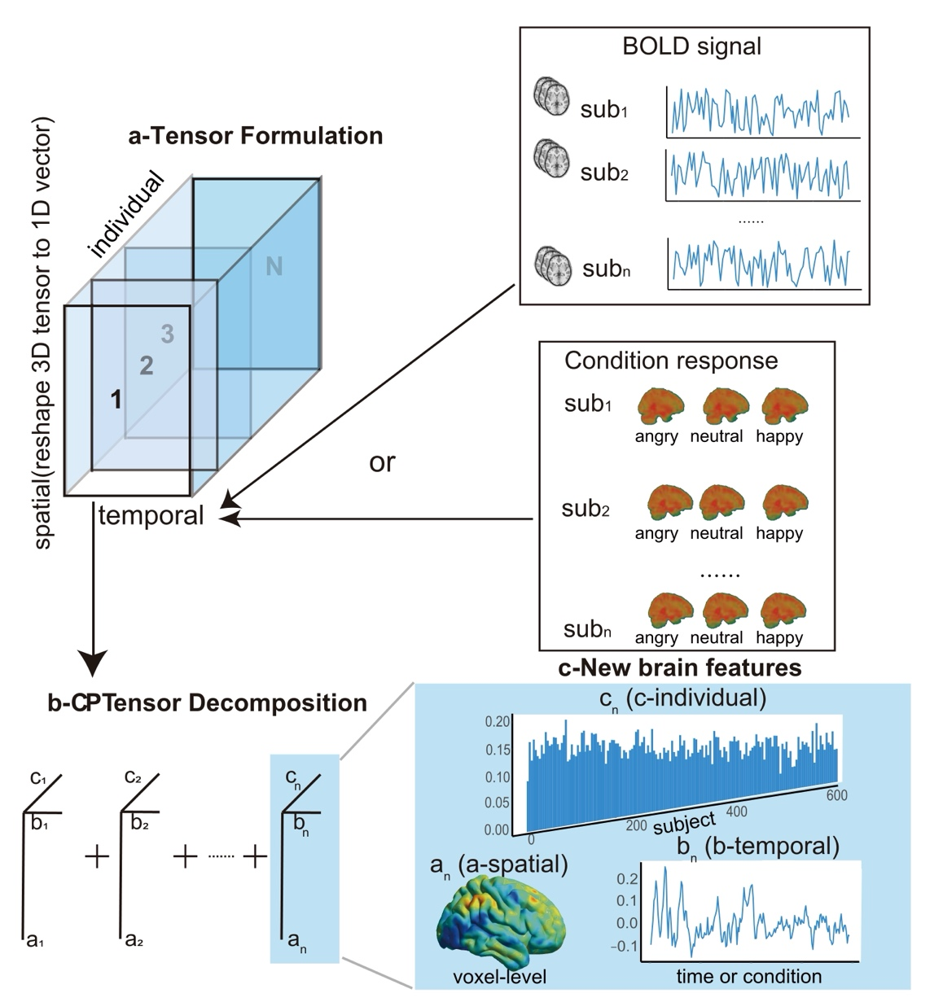
Figure. 1 fMRI Tensor Formulation, Canonical Polyadic Decomposition, and multiscale spatial-temporal-individual features. a. We combine each subject’s BOLD signal or post first-level analysis specific condition response to a 3D tensor. b. We perform Canonical Polyadic Decomposition for the tensor formed above into n CP “basis”. c. We get spatial, temporal and individual features correspondence to aforementioned decomposition.

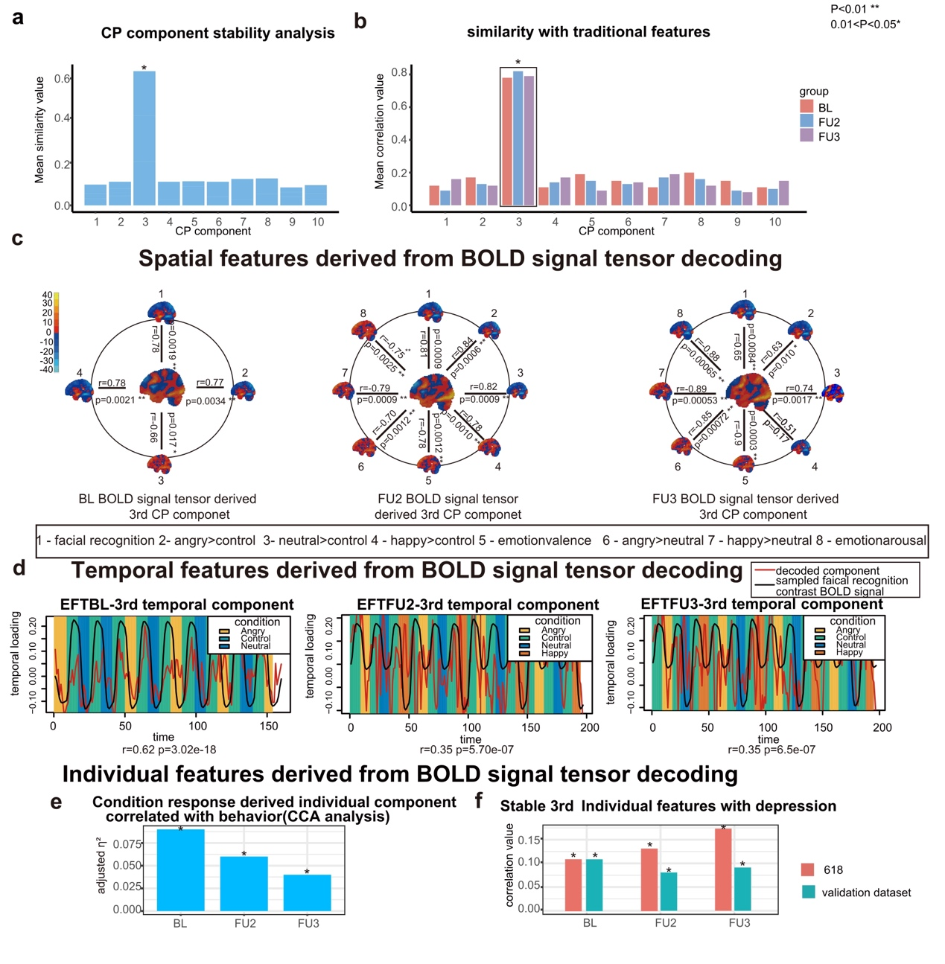
Figure. 2 BOLD signal formed tensor derived CP components’ analysis. a. We calculate first 10 CP components’ similarity in spatial and individual dimension across three followups (temporal dimension is not consistent so the similarity calculation is not applicable), the most stable CP component is the third CP component. b. We correlated spatial and temporal dimension of first 10 CP components with traditional spatial (contrast map) and temporal (BOLD signal derived by first-level analysis) across three followups, the most significant is the third CP component. c. Spatial pattern similarity analysis between BOLD signals derived 3rd CP component and traditional contrast map. d. Temporal pattern similarity analysis between BOLD signals derived 3rd CP component and traditional derived by first-level analysis. e. Canonical correlation analysis between BOLD signal derived individual dimension with behavior scores. f. Correlation analysis between the 3rd CP component with depression scores under discovery dataset (618) and validation dataset.

Figure. 3 Condition response formed tensor derived CP components’ analysis. a. We calculate first 10 CP components’ similarity in spatial and individual dimension across three followups (temporal dimension is not consistent so the similarity calculation is not applicable), the most stable CP component is the first CP component. b. We correlated each spatial and individual dimension of first 10 CP components derived from condition response formed tensor with spatial and individual dimension of third CP component derived from BOLD signal formed tensor across three followups, the most significant is the first CP component. c. Spatial pattern similarity analysis between condition response signals derived 1st CP component and traditional contrast map. d. Temporal loadings plot for condition response tensor derived 1st CP component. e. Canonical correlation analysis & specific correlation between condition response tensor derived individual dimension with behavior scores. f. Correlation analysis between the 1st CP component with depression scores under different circumstance.
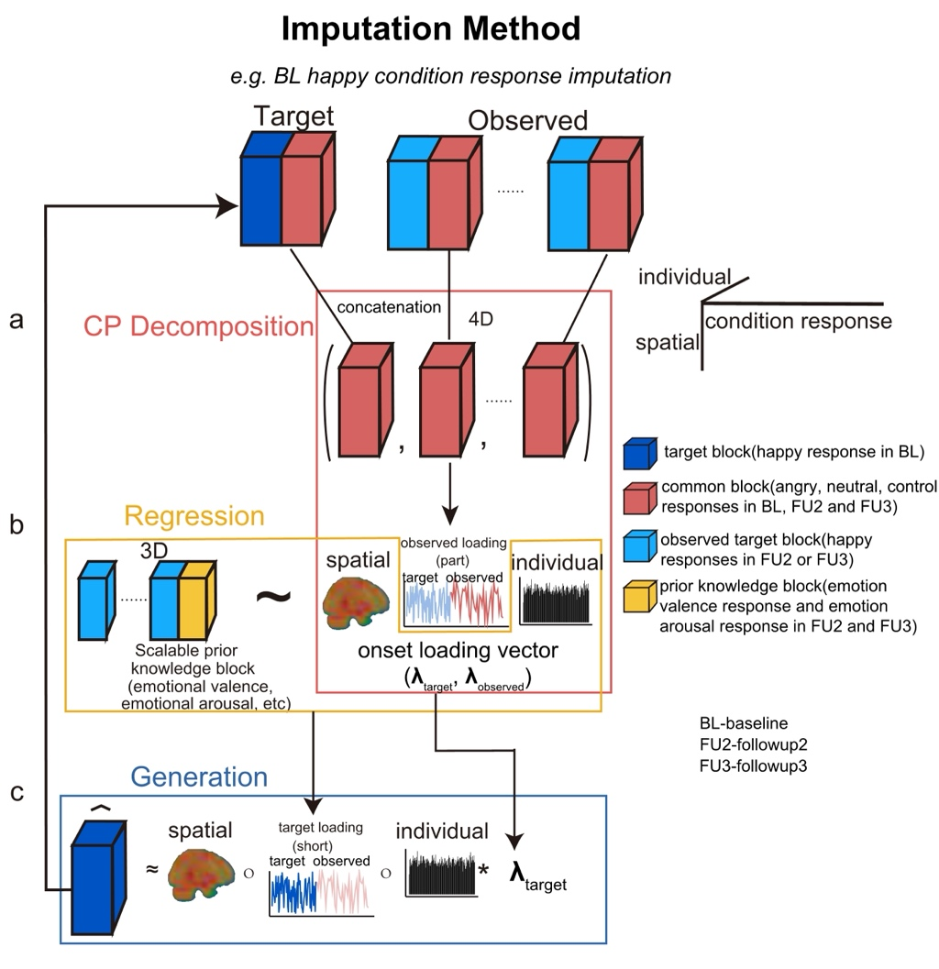
Figure. 4 Decoding-Regression-Generation Pipeline for longitudinal fMRI data imputation. a. Combine the common part (e.g. angry, neutral and control responses of FU2 and FU3) of 3-D target tensor (e.g. BL) and observed tensor (e.g. FU2 and FU3) to form a 4-D tensor and perform the CP decomposition to get the shared spatial, part temporal, individual and time specific onset loading features. b. Regress the combined 3-D target part of observed tensors (e.g. happy responses of FU2 and FU3) (along with prior knowledge block) with shared spatial, individual and specific onset loadings decoded to get the short temporal loading of target tensor. c. Using cross product of regressed short temporal loading and decoded shared spatial, individual and target onset loading features to generate the target part (e.g. happy response of BL) of target tensor (e.g. BL).

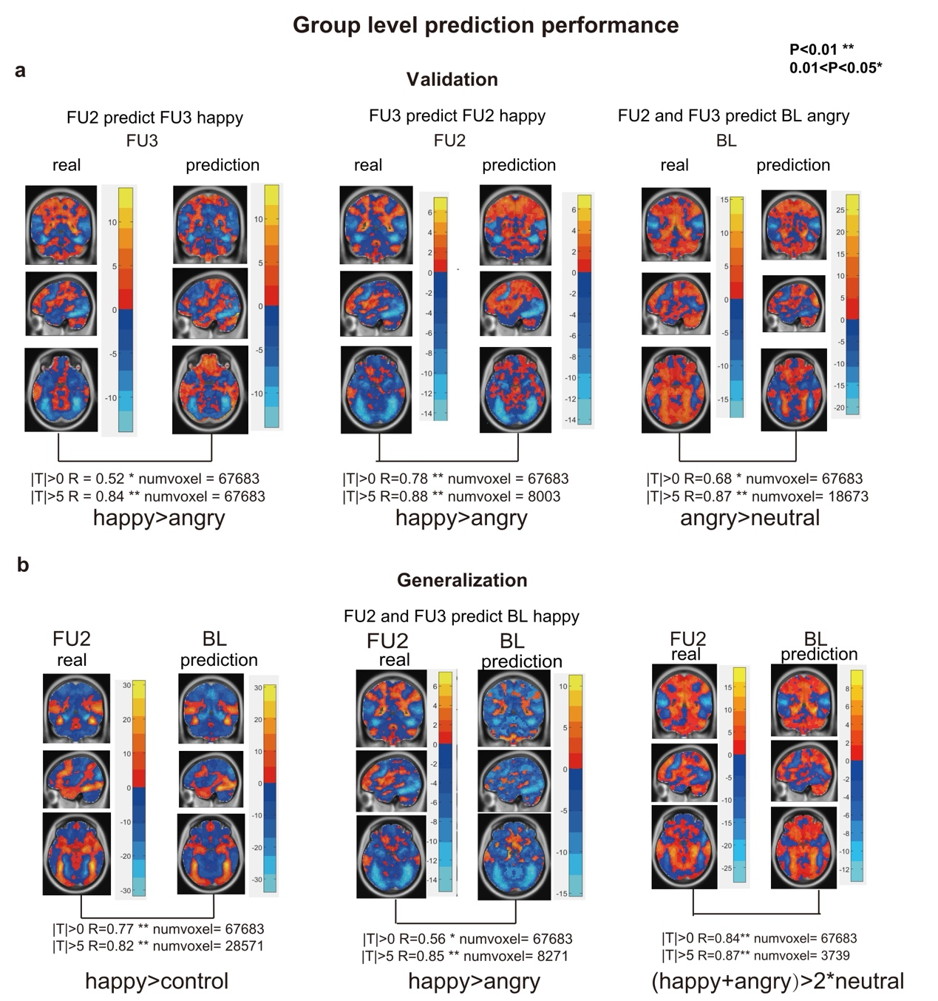
Figure. 5 Group-level Prediction Performance Evaluation. a. First, we validate our method capability at three example cases, use followup2 data to predict followup3 happy response data, use followup3 data to predict followup2 happy response data and use followup2 and followup3 data to predict baseline angry response data. Within these three blocks, the left column is the real response and the right column is the prediction with our method. We calculate the Pearson’s correlation among group-level activation maps and present the detailed statistic value. b. Second, we generalize our method to achieve our final aim, use followup2 and followup3 data to predict the happy response at baseline. We calculate the Pearson’s correlation among group-level activation maps and present the detailed statistic value. The overlay pictures’ coordinate is (40, -46, -20).

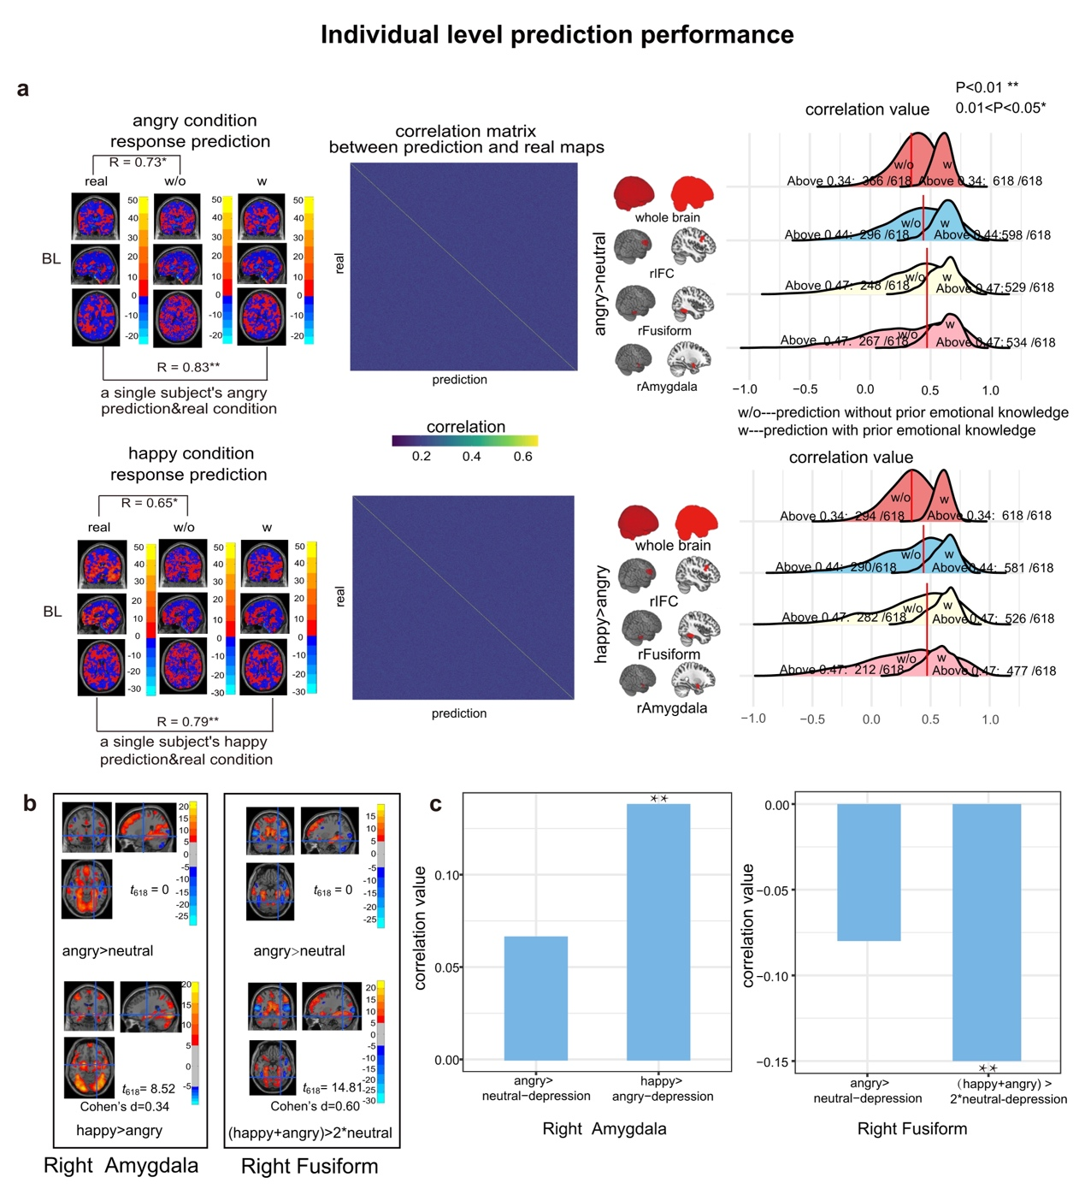
Figure. 6 Individual-level Prediction Performance Evaluation and new findings with happy response in baseline imputed. a. We present individual level prediction sample and real response of four cases in Figure. 5 at the first column. Individual prediction response is significantly similar to the real response. At the second column we present the correlation matrix which formed by correlation of each subject’s predict response and each subject’s real response. The diagonal values were the highest, indicating that for any given individual, their predicted response most closely resembled their own actual response, while showing less similarity to others' responses. At the final column, we present two correlation’s distribution at whole brain scale and three key emotion-related brain regions (rIFC, rAmygdala, rFusiform), we found that when add the prior emotion knowledge, the distribution shift to the right, which means the prediction performance is better. The overlay pictures’ coordinate is (39, -65, -16). b. Significant activations at angry>happy (happy is imputed with our method) contrast but not at angry>neutral in right amygdala, significant activations at (happy+angry)>2*neutral (happy is imputed with our method) contrast but not at angry>neutral. c. Happy>angry activations in right amygdala are significantly correlated with depression scores but not seen in angry>neutral contrast, activations from (happy+angry)>2*neutral contrast in right fusiform are significantly correlated with depression scores but not seen form angry>neutral contrast, and the correlations has been reported in FU2 and FU3.

